**CSE-271: Object-Oriented Programming**

**Exercise #2**

Max Points: 20

|  |  |
| --- | --- |
| **Name:** | Jacob Igel |

|  |  |
| --- | --- |
| Pin | For your own convenient reference – You should first save/rename this document using the naming convention **MUid_Exercise2.docx** (example: raodm_Exercise2.docx) prior to proceeding with this exercise. |

|  |
| --- |
| **Objectives**: The objectives of this exercise are to:   1. Understand the concept of exceptions 2. Explore the use of throw and throws keywords to generate exceptions 3. Trace the behavior of exceptions using a debugger 4. Develop a short program involving exception handling.   Fill in answers to all of the questions. For some of the questions you can simply copy-paste appropriate text from Eclipse output into this document. You may discuss the questions or seek help from your neighbor, TA, and/or your instructor. |

# Part #0: One time setup of Eclipse (IDE) – Only if needed

|  |  |
| --- | --- |
| Eclipse Logo A2 by dj-fahr on DeviantArt | We already configured Eclipse’s source formatter and Checkstyle plug-in as part of Lab #1. If your Eclipse is not configured (because you are using a different computer) then use the instructions from Lab #1 to configure Eclipse. |

# Part #1: Basics of exceptions in Java

*Estimate time: 30 minutes*

**Background**: Clearly and concisely explaining concepts is a very important skills for your future job-interviews and in your jobs. Hence, the exams also involve such questions and in the labs we will practice this style of questions.

**Exercise**: Briefly (2-to-3 sentences each) respond to the following questions regarding the basic concepts of exceptions in Java.

1. What is an exception in the context of Java programming language?

|  |
| --- |
| An exception is a problem that could happen during the execution of a program. The natural flow of the program is interrupted, and it ends abnormally. We then use exception handling to properly handle these issues. |

1. Using a 1-line Java source code, illustrate how exceptions are generated in Java using the throw keyword.

|  |
| --- |
| throw new FileNotFoundException (“File Not Found”) |

1. Briefly describe (English description is sufficient, but you can provide a short example source code too) how exceptions can be handled (or caught) and processed.

|  |
| --- |
| “**exception handling** is the process of responding to the occurrence of *exceptions*”  We use a try, catch, and a finally (optional) block to handle these exceptions.  try {  // create a file reader  Scanner fileReader = new Scanner(new File(fileName));  while (fileReader.hasNext()) {  // creating the x & y coordinates for the point object  int x = fileReader.nextInt();  int y = fileReader.nextInt();  Point list = new Point(x, y);  arr.add(list);  }  //close the file reader  fileReader.close();  } catch (FileNotFoundException e) {  System.***out***.println("An error occurred.");  e.printStackTrace();  } |

1. What is the purpose of a finally block (used with a try statement) in Java?

|  |
| --- |
| A *finally* block executes whether the exception gets handled or not. This means that any statements that are in there are handled regardless of there being an exception being called or not. |

1. In Java, what is the difference between a checked and unchecked exception in Java?

|  |
| --- |
| Checked Exception – If code uses a checked exception, the method must handle it or it must specify the exception using ‘throws’  Unchecked Exception - These exception are not forced to be handled or specify the exception. |

1. Referring to the Javadoc (<https://docs.oracle.com/javase/8/docs/api/>), indicate if the following exception classes are checked or unchecked exception classes.
   * 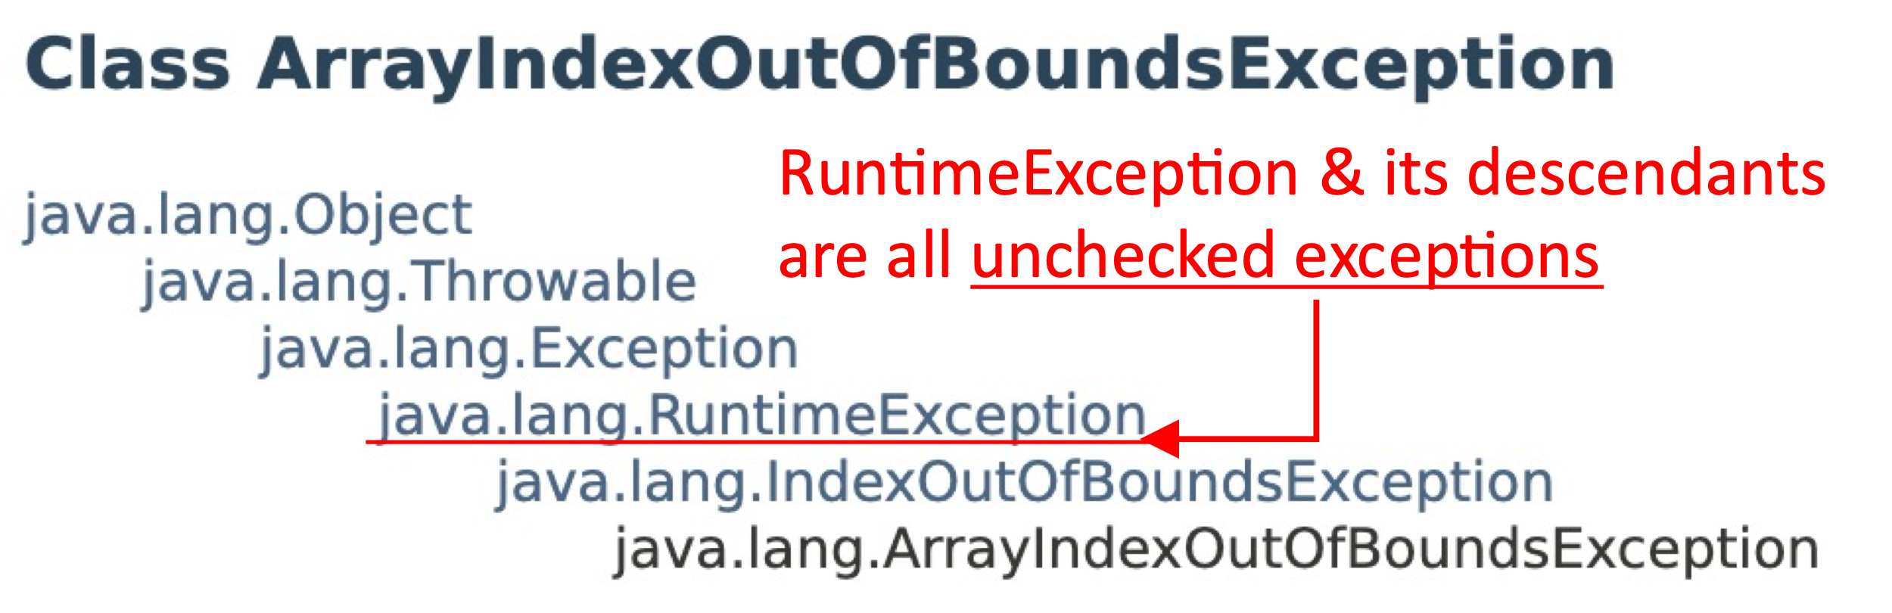**You expected to memorize**: RuntimeException and its descendants are unchecked exceptions. All other Throwable and Exception classes and their descendants are checked exceptions and must be included in the throws clause of a method.

|  |  |  |
| --- | --- | --- |
| **Exception class name** | | **Checked/Unchecked?** |
| a. | FileNotFoundException | Checked |
| b. | ArrayIndexOutOfBoundsException | Unchecked |
| c. | ClassCastException | Unchecked |
| d. | CloneNotSupportedException | Checked |
| e. | OutOfMemoryError | Unchecked |

1. Complete the signature of the methods shown below to include the throws clause with appropriate final exception types:

|  |  |  |
| --- | --- | --- |
| **public** **void** process(String s) |  | **public** **void** process(**int** i) |
| Throws PrintException |  | Throws ParseException, PrintException |
| {  // Some java code goes here.  **throw** **new** PrintException();  } |  | {  // Some java code goes here.  **switch**(i) {  **case** 0: **throw** **new** ParseException();  **case** 1: **throw** **new** PrintException();  }  } |

1. Write the Java code for a void method named processInt that accepts an int as a parameter and prints it, if the integer is not zero. If the parameter is zero, then it should throw an InvalidPropertiesFormatException, with the message “Parameter was zero!”. Don’t forget the throws clause for the method.

|  |
| --- |
| public void processInt(int p) throws InvalidPropertiesFormatException {  if (p == 0) {  throw new InvalidPropertiesFormatException(“Parameter was zero!);  }  System.out.print(p);  } |
|  |

# Part #2: Tracing exceptions via the debugger

*Estimated time: < 20 minutes*

**Background**: The best way to build a strong mental model of exception propagation is to observe (or trace) the operations using the debugger. Debugger is an invaluable tool to build a strong mental model, immaterial of the programming language you use.

**Exercise**: Trace the operation of exception propagation using the following procedure:

1. Launch Eclipse (IDE) using the default workspace.
2. 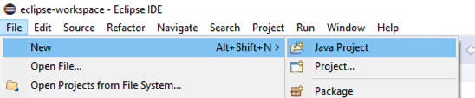Next, from Eclipse’s main menu use the option File ® New ® Java project to create a new Java project titled lab2. Don’t create any modules.
3. From Canvas, download the supplied starter code for this lab directly to the directory of your newly created Java project. Refresh your project after you have downloaded the files so that it shown in Eclipse.
4. 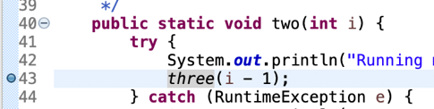In order to use the debugger, you first need to set a breakpoint. Set a breakpoint in method two, on the line of code where three(i – 1) method is called as shown in the adjacent figure.
5. Run the program via the debugger. The debugger will stop at the breakpoint you have set. When prompted switch over to the debug perspective.
6. Step into method calls for three and four to the line code just before an exception is thrown at the line “**throw** **new** RuntimeException("even number");”. Now, make a screenshot of the entire Eclipse window (ensure the call stack is visible) and place it in the space below:

|  |
| --- |
| Place screenshot of debugger here:   |

1. Next, continue stepping through the code until the call stack unwinds all the way to the main method. As you step through the code make a mental model of how the stack trace is unwinding.
2. Once the stack trace unwinds to the end of one method make another screenshot of your Eclipse window and place it in the space below:

|  |
| --- |
| Place screenshot of debugger here:   |

1. Using information from lecture and experience from the debugger tracing you just did, briefly (2-to-3 sentences) state the rules that Java uses to propagate an exception as the call stack to unwinds.

|  |
| --- |
| If the method is surrounded by a try catch block that handles the certain the exception, the catch block starts to execute. If it is not executed, the finally block is executed. |

# Part #3: Manually tracing programs involving exceptions

*Estimated time: 20 minutes*

1. Given the following implementation for a mystery method, illustrate the output generated by the calls to the mystery method shown below:

|  |
| --- |
| **public** **static** **final** String ***Stars*** = "********************";  **public** **static** **void** other(**int** n) **throws** Exception {  **if** (n % 2 == 0) {  **throw** **new** Exception(n + " is even.");  }  }  **public** **static** **void** mystery(**int** n) **throws** Exception {  **if** (n < 0) {  **throw** **new** Exception("negative!");  }  **try** {  *other*(n - 1);  System.***out***.println(***Stars***.substring(0, n));  } **catch** (Exception e) {  System.***out***.println(e.getMessage());  } **finally** {  System.***out***.println("Done.");  }  } |

* 1. What is the output generated by the method call: mystery(4)?

|  |
| --- |
| **** Done. |

* 1. What is the output generated by the method call: mystery(3)?

|  |
| --- |
| 2 is even.  Done. |

* 1. What is the output generated by the method call: mystery(-2)?

|  |
| --- |
| Exception(“negative!”) |

1. Given the following implementation for method1 and helper methods, illustrate the output generated by the following calls to method1. Assume Exp1, Exp2, Exp3, and Exp4 are checked exception classes.

|  |  |
| --- | --- |
| **public** **static** **void** method1(**int** i) **throws** Exp4 {  **try** {  *helper*(i);  System.*out*.println("method1 OK");  } **catch** (Exp1 e1) {  System.*out*.println("method1 error");  }  }  **public** **static** **void** helper(**int** i) **throws** Exp1, Exp4 {  **try** {  **switch**(i) {  **case** 0: **throw** **new** Exp1();  **case** 1: **throw** **new** Exp4();  **case** 2: **throw** **new** Exp2();  **case** 3: System.*out*.println("helper OK");  }  } **catch** (Exp2 e2) {  System.*out*.println("helper error");  } **finally** {  System.*out*.println("helper done");  }  } | **What is the output from method1(3)?** |
| helper OK  helper done  method1 OK` |
| **What is the output from method1(2)?** |
| helper error  helper done  method1 OK |
| **What is the output from method1(0)?** |
| helper done  mehtod1 error |

# Part #4: Develop a simple Java program

*Estimated time: 20 minutes*

**Background**: Handling exceptions in a Java program can be used for developing a “trial-and-error” approach for problem-solving. In this “trial-and-error” approach, a program can attempt a simple operation. If the operation generates an exception (i.e., it fails) then we can infer certain properties. For example, the Integer.parseInt method can be used to convert a string to an integer. This method throws a NumberFormatException if the parameter is not an integer. Using the presence or absence of an exception, we can detect if an input String is an integer.

**Exercise**: In this part of the exercise, you are expected to develop a simple Java program to detect if a word (entered by the user) is an int, double, or String. Develop the program in the following manner:

1. You can reuse your current Eclipse project or create a new Java project in Eclipse.
2. Create a new class called Numero with a main method. You will be developing the main method in the following manner:
   1. Prompt the user to enter a word via System.***out***.println("Enter a word or a number: ")
   2. Read a word from the user from System.in using a suitable Scanner object.
   3. Next use two try…catch blocks to detect the input word’s type. First, use Integer.parseInt to convert the word to int. If that succeeds the input word is an integer. If not, use Double.parseDouble method to try and convert the word to double. If that succeeds the word is a double. Otherwise assume the type of String.
   4. Print the word and its type via: System.***out***.println(word + " is a " + type);

**Sample outputs:**

Sample outputs from independent runs of the completed program are shown below. User inputs are in **green** color.

|  |
| --- |
| Enter a word or a number:  123  123 is a int |
| Enter a word or a number:  12.3  12.3 is a double |
| Enter a word or a number:  12,3  12,3 is a String |

# Part #5: Submit to Canvas via CODE plug-in

*Estimated time: < 5 minutes*

**Exercise:** You will be submitting the following files via the Canvas CODE plug-in:

1. This MS-Word document saved as a PDF file – **Do not upload Word documents. Only submit PDF file**.
2. The Java program (Numero) that you developed in this exercise

Ensure you actually complete the submission on Canvas.